**Image Recognition with IBM Cloud Visual Recognition**

**Team Members:**

1.732721104035 – Nandhu K

2.732721104036 – Navaneetha C

3.732721104039 – Poojasri G

4.732721104040 – Pradeepa R

5.732721104045 – Sowmika V

**Phase 5:Project Documentation & Submission**

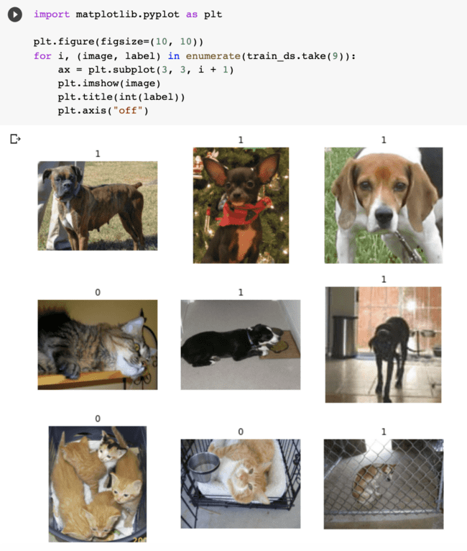

Introduction:

* Image recognition - It is the process of using technology to interpret and understand the content of visual data, such as images or videos. It involves the use of algorithms and machine learning to identify and categorize objects, patterns, or features within the visual input, enabling computers to "recognize" and make sense of visual information. This technology has diverse applications, ranging from facial recognition and object detection to medical image analysis and autonomous vehicles.
* IBM Cloud Visual Recognition - It is a powerful service that integrates image recognition capabilities into the cloud environment. Leveraging advanced machine learning algorithms, it allows developers to build applications that can analyze and interpret visual content. Whether you're automating business processes, enhancing user experiences, or creating innovative solutions, IBM Cloud Visual Recognition provides a scalable and efficient platform. With features like custom model training, you can tailor the system to recognize specific content relevant to your needs. Explore the synergy between IBM Cloud and image recognition to unlock new possibilities in visual intelligence.
* Image recognition with IBM Cloud Visual Recognition - Uncover the power of cutting-edge technology as we delve into the capabilities and applications that make this tool a game-changer in the realm of visual analysis. Whether you're a tech enthusiast or a professional seeking innovative solutions, buckle up for a journey into the future of image recognition with IBM Cloud Visual Recognition.

Objective:

The primary objective of image recognition is to develop computer systems that can accurately and autonomously perform tasks such as object detection, classification, facial recognition, text recognition, content moderation, medical imaging diagnosis, and various other applications by analyzing and interpreting the content of digital images. These systems use advanced algorithms and machine learning techniques to recognize patterns, objects, or information within images, making them essential in fields ranging from healthcare and autonomous vehicles to security, e-commerce, and entertainment, ultimately enhancing automation, decision-making, and user experiences in diverse industries.

Design Thinking:

Design thinking for image recognition involves a human-centric approach to address user needs and challenges in developing image recognition systems. It begins with empathizing with users to understand their context, followed by defining specific problems and opportunities. The ideation phase explores various solutions, while rapid prototyping and testing help iterate and refine the design. Collaboration and feedback from users play a central role in this process, ensuring that the image recognition system is both technologically sound and user-friendly, and that it effectively addresses real-world issues and requirements

PROBLEM STATEMENT:

1. Image processing can be broadly defined as the manipulation of

signals which are inherently multidimensional.

2. The most common such signals are photographs and video

sequences.

3. The goals of processing or manipulation can be (i) compression for

storage or transmission; (ii) enhancement or restoration; (iii)

analysis, recognition, and understanding; or (iv) visualization for

human observers.

PROBLEM DEFINITION:

1. The project involves creating an image recognition system

using IBM Cloud Visual Recognition.

2. The goal is to develop a platform where users can upload

images, and the system accurately classifies and describes the image

contents.

3. This will enable users to craft engaging visual stories with the

help of AI-generated captivating visuals and compelling narratives.

PROBLEM STATEMENT:

1. Image processing can be broadly defined as the manipulation of

signals which are inherently multidimensional.

2. The most common such signals are photographs and video

sequences.

3. The goals of processing or manipulation can be (i) compression for

storage or transmission; (ii) enhancement or restoration; (iii)

analysis, recognition, and understanding; or (iv) visualization for

human observers.

PROBLEM DEFINITION:

1. The project involves creating an image recognition system

using IBM Cloud Visual Recognition.

2. The goal is to develop a platform where users can upload

images, and the system accurately classifies and describes the image

contents.

3. This will enable users to craft engaging visual stories with the

help of AI-generated captivating visuals and compelling narratives.

PROBLEM STATEMENT:

1. Image processing can be broadly defined as the manipulation of

signals which are inherently multidimensional.

2. The most common such signals are photographs and video

sequences.

3. The goals of processing or manipulation can be (i) compression for

storage or transmission; (ii) enhancement or restoration; (iii)

analysis, recognition, and understanding; or (iv) visualization for

human observers.

PROBLEM DEFINITION:

1. The project involves creating an image recognition system

using IBM Cloud Visual Recognition.

2. The goal is to develop a platform where users can upload

images, and the system accurately classifies and describes the image

contents.

3. This will enable users to craft engaging visual stories with the

help of AI-generated captivating visuals and compelling narratives.

Problem statement:

1. Image processing can be broadly defined as the manipulation of signals which are inherently multidimensional.

2. The most common such signals are photographs and video sequences.

3. The goals of processing or manipulation can be

(i) compression forstorage or transmission;

(ii) enhancement or restoration;

(iii) analysis, recognition, and understanding; or

(iv) visualization for human observers.

problem definition:

1. The project involves creating an image recognition system using IBM Cloud Visual Recognition.

2. The goal is to develop a platform where users can upload images, and the system accurately classifies and describes the image contents.

3. This will enable users to craft engaging visual stories with thehelp of AI-generated captivating visuals and compelling narratives.

Development Phases:

1. Data collectionTo achieve image recognition, machine vision artificial intelligence models are fed with pre-labeled data to teach them to recognize images they’ve never seen before.
2. Pre-processing of the image dataOnce the dataset is ready, there are several things to be done to maximize its efficiency for model training.
3. Model architecture and training processDue to their unique work principle, convolutional neural networks (CNN) yield the best results with deep learning image recognition. The complete pixel matrix is not fed to the CNN directly as it would be hard for the model to extract features and detect patterns from a high-dimensional sparse matrix. Instead, the complete image is divided into small sections called feature maps using filters or kernels.
4. Traditional machine learning algorithms for image recognitionBefore the development of parallel processing and extensive computing capabilities required for training deep learning models, traditional machine learning models had set standards for image processing.
5. Popular deep learning models for image recognitionSingle-shot detectors divide the image into a default number of bounding boxes in the form of a grid over different aspect ratios. The feature map that is obtained from the hidden layers of neural networks applied on the image is combined at the different aspect ratios to naturally handle objects of varying sizes.

User Interface:

<html lang="en">

    <head>

        <meta charset="UTF-8" />

        <meta name="viewport"

              content="width=device-width,

                       initial-scale=1.0" />

        <title>Image Classifier using ML5 js</title>

        <script src=

"<https://unpkg.com/ml5@0.4.3/dist/ml5.min.js>">

        </script>

    </head>

    <body>

        <center>

            <h1 style="color: green;">GeeksforGeeks</h1>

            <b>

                Image Classification using Javascript

            </b>

            </br>

            <img src="" alt="" id="image"

                 width="315px" height="200px" />

            </br></br>

            <input type="file" accept="image/*"

                   onchange="loadFile(event)"

                   name="image" id="file" />

            <button onclick="predict()">Predict</button>

        </center>

    </body>

</html>

Technical Implementation:

* Classification:

Artificial neural networks identify objects in the image and assign them one of the predefined groups or classifications.

* Detection:

The process of classification and localization of an object is called object detection. Once the object's location is found, a bounding box with the corresponding accuracy is put around it. Depending on the complexity of the object, techniques like [bounding box annotation](https://www.v7labs.com/blog/bounding-box-annotation), [semantic segmentation](https://www.v7labs.com/blog/semantic-segmentation-guide), and key point annotation are used for detection.

* Tagging:

Tagging is similar to classification but aims for better accuracy. It tries to identify multiple objects in an image. Therefore, an image can have one or more tags. Returning to the example of the image of a road, it can have tags like 'vehicles,' 'trees,' 'human,' etc.

* Segmentation:

[Instance segmentation](https://www.v7labs.com/blog/instance-segmentation-guide) is the detection task that attempts to locate objects in an image to the nearest pixel. Instead of aligning boxes around the objects, an algorithm identifies all pixels that belong to each class. Image segmentation is widely used in medical imaging to detect and label image pixels where precision is very important.

Development Phase 3:

Image Recognition using Sentiment Analysis

import pandas as pd    # to load dataset

import numpy as np     # for mathematic equation

from nltk.corpus import stopwords   # to get collection of stopwords

from sklearn.model_selection import train_test_split       # for splitting dataset

from tensorflow.keras.preprocessing.text import Tokenizer  # to encode text to int

from tensorflow.keras.preprocessing.sequence import pad_sequences   # to do padding or truncating

from tensorflow.keras.models import Sequential     # the model

from tensorflow.keras.layers import Embedding, LSTM, Dense # layers of the architecture

from tensorflow.keras.callbacks import ModelCheckpoint   # save model

from tensorflow.keras.models import load_model   # load saved model  
def load_dataset():

    df = pd.read_csv('/content/IMDB_Dataset (1).csv')

    x_data = df['review']       # Reviews/Input

    y_data = df['sentiment']    # Sentiment/Output

    # PRE-PROCESS REVIEW

    x_data = x_data.replace({'<.*?>': ''}, regex = True)          # remove html tag

    x_data = x_data.replace({'[^A-Za-z]': ' '}, regex = True)     # remove non alphabet

    x_data = x_data.apply(lambda review: [w for w in review.split() if w not in english_stops])  # remove stop words

    x_data = x_data.apply(lambda review: [w.lower() for w in review])   # lower case  
 # ENCODE SENTIMENT -> 0 & 1

   y_data = y_data.replace('positive', 1)  
  y_data = y_data.replace('negative', 0)

    return x_data, y_data

x_data, y_data = load_dataset()

print('Reviews')

print(x_data, '\n')

print('Sentiment')

print(y_data)

Output:

0 1

1 1

2 1

3 0

4 1

..

49995 1

49996 0

49997 0

49998 0

49999 0

Name: sentiment, Length: 50000, dtype: int64

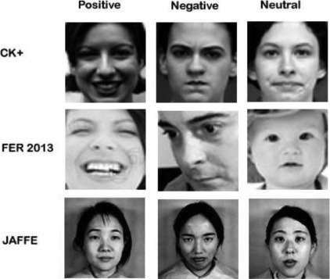

Development Phase 4:

Image Recognition using Natural Language Processing

from tensorflow import keras

from tensorflow.keras import layers

data_augmentation = keras.Sequential(

  [layers.RandomFlip("horizontal"), layers.RandomRotation(0.1),]

)

base_model = keras.applications.Xception(

  weights="imagenet",  # Weights pre-trained on ImageNet.

  input_shape=(150, 150, 3),

  include_top=False,

)

base_model.trainable = False

# Create a new model on top

inputs = keras.Input(shape=(150, 150, 3))

x = data_augmentation(inputs)  # Apply random data augmentation

base_model.trainable = True

model.compile(

  optimizer=keras.optimizers.Adam(1e-5),  # Low learning rate

  loss=keras.losses.BinaryCrossentropy(from_logits=True),

  metrics=[keras.metrics.BinaryAccuracy()],

)

epochs = 10

model.fit(train_ds, epochs=epochs, validation_data=validation_ds)

! pip install transformers

from transformers import pipeline

classifier = pipeline('sentiment-analysis')

classifier('I am finding the article about Transfer learning very useful.')

Output:

[{'label': 'POSITIVE', 'score': 0.9968850016593933}]

url = "<https://ai.stanford.edu/~amaas/data/sentiment/aclImdb_v1.tar.gz>"

dataset = tf.keras.utils.get_file("aclImdb_v1.tar.gz", url,

                                untar=True, cache_dir='.',

                                cache_subdir='')

dataset_dir = os.path.join(os.path.dirname(dataset), 'aclImdb')

os.listdir(dataset_dir)

# Embed a 1,000-word vocabulary into 5 dimensions.

embedding_layer = tf.keras.layers.Embedding(1000, 5)

# text vectorization layer to split, and map strings to integers.

vectorize_layer = TextVectorization(

  standardize=custom_standardization,

  max_tokens=vocab_size,

  output_mode='int',

  output_sequence_length=sequence_length)

model = Sequential([

vectorize_layer,

Embedding(vocab_size, embedding_dim, name="embedding"),

GlobalAveragePooling1D(),

Dense(16, activation='relu'),

Dense(1)

])

model.compile(optimizer='adam',

            loss=tf.keras.losses.BinaryCrossentropy(from_logits=True),

            metrics=['accuracy'])

Use Cases of Image Recognition in our Daily Lives:

1. Image recognition helps you catch catfish accounts :

One of the most important use cases of image recognition is that it helps you unravel fake accounts on social media. You must know that the trend of fake accounts has increased over the past decade. Today people make fake accounts for online scams, the damaging reputation of famous people, or spreading fake news. Here you should know that image recognition techniques can help you avoid being prey to digital scams. You can simply search by image and find out if someone is stealing your images and using them on another account. So the first most important reason behind the popularity of image recognition techniques is that it helps you catch catfish accounts.

2. Image recognition is being used in facial recognition and other security systems:

Image recognition is also considered important because it is one of the most important components in the security industry. Today it is being used in all kinds of security systems. The most common example of image recognition can be seen in the facial recognition system of your mobile. Facial recognition in mobiles is not only used to identify your face for unlocking your device; today, it is also being used for marketing. Image recognition algorithms can help marketers get information about a person’s identity, gender, and mood. There are many more use cases of image recognition in the marketing world, so don’t underestimate it.

3. Image recognition is used in Reverse Image Search for different purposes :

You might have heard of the online reverse image search. Reverse picture search is a method that can make a search by image for free. With modern [reverse image search](https://searchenginereports.net/reverse-image-search) utilities, you can search by an image and find out relevant details about it. Image finder uses [artificial intelligence software](https://www.comidor.com/cognitive-automationai/) and image recognition techniques to identify images’ contents and compare them with billions of images indexed on the web. The image recognition algorithms help find out similar images, the origin of the image in question, information about the owner of the image, websites using the same image, image plagiarism, and all other relevant information. In the past reverse image search was only used to find similar images on the web. But today, you can use it for dozens of different purposes.

4. Government agencies are using image recognition  :

You would be surprised to know that image recognition is also being used by government agencies. These agencies search images to collect information about people. Today police and other secret agencies are generally using image recognition technology to recognize people in videos or images.

5. Image recognition also plays an important role in the healthcare industry :

Today, image recognition is also important because it helps you in the healthcare industry. Here you should know that image recognition is widely being used across the globe for detecting brain tumors, cancer, and even broken images. Image recognition techniques and algorithms are helping out doctors and scientists in the medical treatment of their patients. Nowadays,  image recognition is also being used to help visually impaired people. Also, new inventions are being made every now and then with the use of image recognition. High-tech walking sticks for blind people are one of the most important examples in this regard.

6. Image recognition is also empowering the eCommerce industry :

Today image recognition is also being used in the e-commerce industry. The visual search market has drastically increased in the past. This is major because today customers are more inclined to make a search by product images instead of using text.

Advantages:

* Automation: Image recognition technology can automate tasks that require visual analysis, such as quality control in manufacturing or content moderation on social media platforms.
* Enhanced Security: It is used in security systems for facial recognition and object detection, improving authentication and surveillance.
* Medical Diagnosis: Image recognition aids in the early detection of medical conditions through the analysis of medical images, like X-rays and MRIs.
* Improved User Experience: It enhances user experiences in applications like augmented reality, where it recognizes real-world objects and overlays digital information.
* Data Insights: Image recognition can extract valuable insights from images, helping businesses in industries like retail understand customer preferences and behaviors.

Disadvantage:

* Limited accuracy: Image recognition systems may struggle to accurately identify objects in complex or cluttered scenes, leading to errors and misclassifications.
* High computational requirements: Image recognition often demands significant computing power and resources, making it challenging for low-power or resource-constrained devices.
* Sensitivity to variations: Changes in lighting, angle, or perspective can affect the performance of image recognition algorithms, making them less robust in real-world conditions.
* Data bias: Image recognition models can be biased if they are trained on datasets that do not adequately represent the diversity of objects, people, or scenes, potentially leading to unfair or inaccurate results.
* Privacy concerns: The use of image recognition technology has raised privacy concerns, as it can be used for surveillance and tracking without consent, leading to potential violations of personal privacy and civil liberties.

Conclusion:

In conclusion, image recognition has emerged as a transformative technology with a wide range of applications across various industries, from healthcare and manufacturing to entertainment and security. The ability of machines to understand and interpret visual content has opened doors to automation, efficiency, and innovation. However, the successful development and deployment of image recognition systems hinge on rigorous problem definition, high-quality data, model selection, and ethical considerations. Moreover, the iterative nature of the development process, including validation, feedback, and continuous improvement, is crucial for maintaining accuracy and relevance in ever-evolving real-world contexts. As image recognition continues to advance, it promises to play a central role in enhancing user experiences, decision-making processes, and overall quality of life. It also necessitates a commitment to responsible and ethical AI practices to ensure that the technology benefits society as a whole.